LAB 2 Explanations

Experiment 1: Signal Generator and Oscilloscope

Objective
The objective of this experiment is to study the behavior of a sinusoidal signal in a resistive circuit and to observe the input and output waveforms using an oscilloscope.

Theory
A signal generator is used to generate electrical signals such as sine waves with different frequencies and amplitudes. An oscilloscope is used to visualize these signals and measure parameters such as voltage, frequency, and time period.
In a series resistor circuit, the input voltage is divided among the resistors according to their resistance values. This is known as the voltage divider rule. The waveform across each resistor remains sinusoidal, but its amplitude changes depending on the resistor value.

Procedure (Steps)
- Open Proteus software and create a new schematic design.
- Place a Signal Generator from the library on the schematic.
- Place two resistors in the circuit:
  - R1 = 5.1 kΩ
  - R2 = 3.3 kΩ
- Connect the resistors in series with the signal generator as shown in the circuit diagram.
- Connect the ground terminal of the signal generator to the circuit ground.
- Place an Oscilloscope in the circuit.
- Connect the oscilloscope probes:
  - Channel A across the input signal
  - Channel B across R1
  - Then move the probe to measure voltage across R2
- Set the signal generator frequency to 100 Hz.
- Set the peak-to-peak voltage to 5V.
- Run the simulation and observe the waveforms on the oscilloscope.
- Record the input voltage waveform and the voltage waveforms across R1 and R2.
- Take screenshots of the oscilloscope display for documentation.
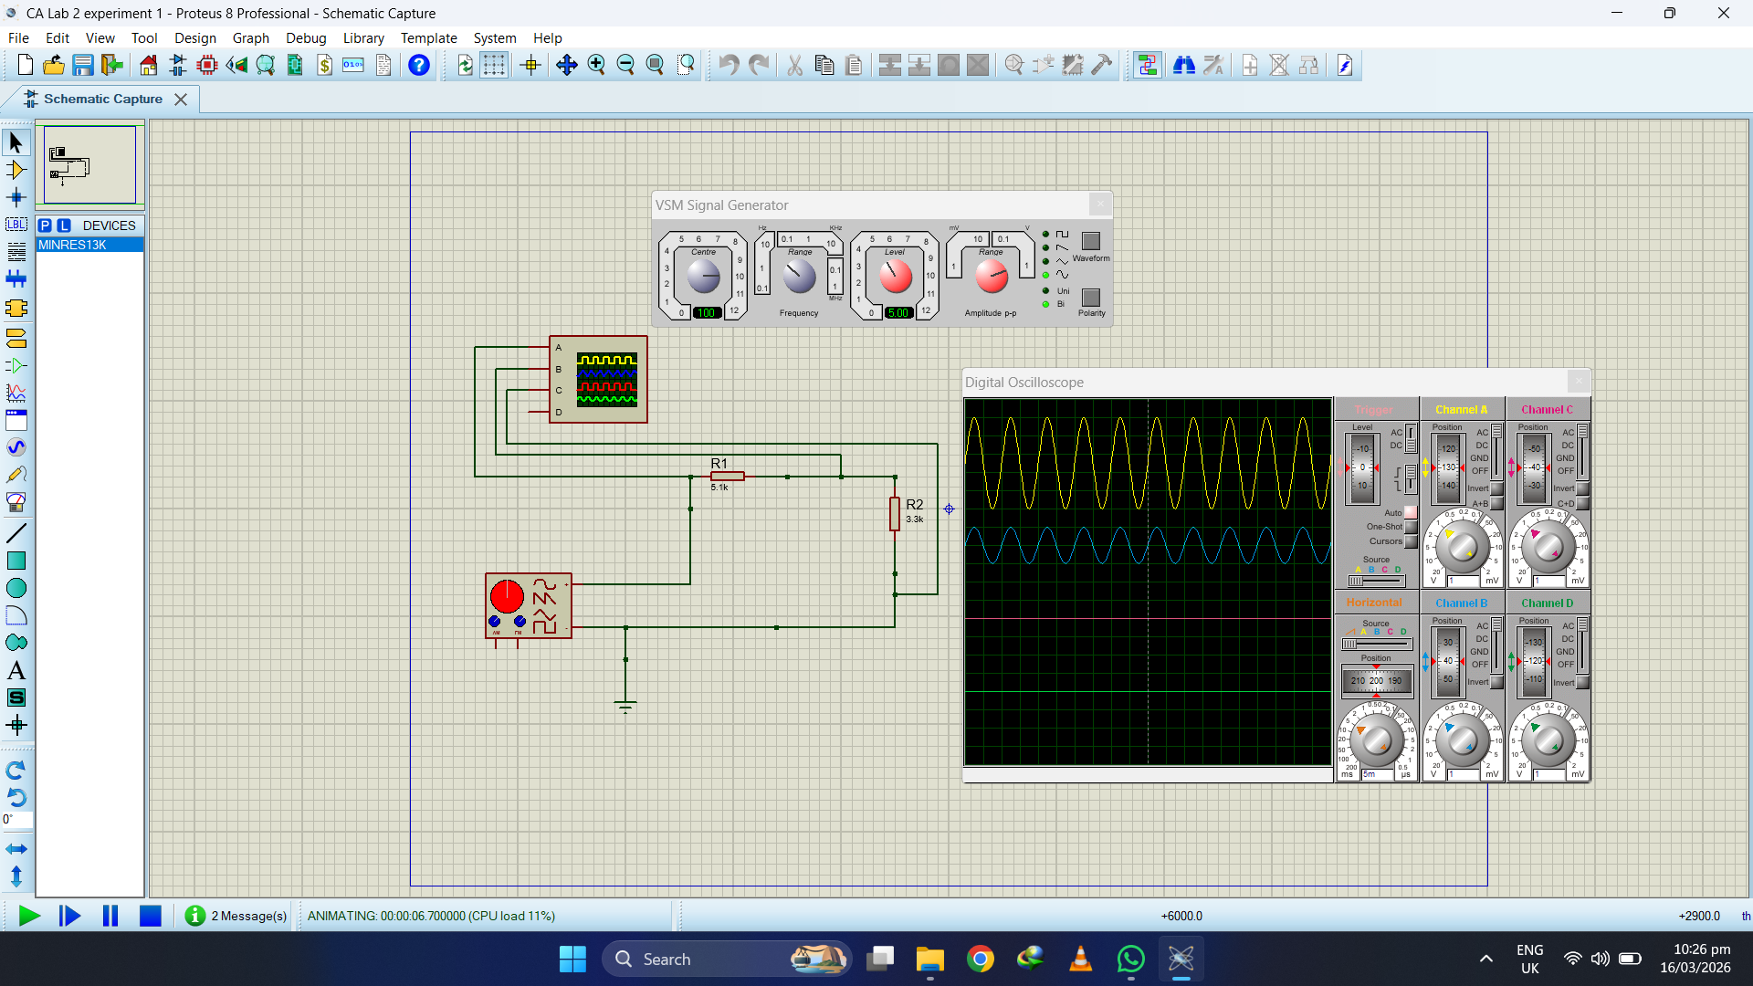
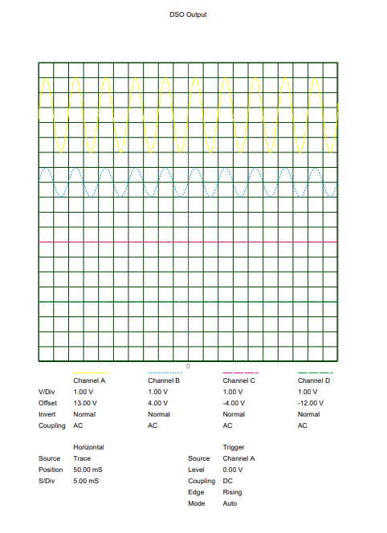

Experiment 2: Signal Generator and Oscilloscope

Objective
The objective of this experiment is to analyze voltage distribution in a three-resistor series circuit and observe the waveforms using an oscilloscope.

Theory
When multiple resistors are connected in series, the total resistance is the sum of all individual resistances. The input voltage is divided among the resistors according to their resistance values.
The waveform shape remains the same (sinusoidal), but the amplitude across each resistor changes due to voltage division.

Procedure (Steps)
- Open Proteus software and create a new schematic.
- Place a Signal Generator in the circuit.
- Place three resistors with the following values:
  - R1 = 4.7 kΩ
  - R2 = 3.3 kΩ
  - R3 = 5.1 kΩ
- Connect all resistors in series with the signal generator.
- Connect the ground terminal of the signal generator to the circuit ground.
- Place an Oscilloscope in the circuit.
- Connect the oscilloscope probes to measure:
  - Input voltage
  - Voltage across R1
  - Voltage across R2
  - Voltage across R3
- Set the signal generator frequency to 200 Hz.
- Set the peak-to-peak voltage to 7V.
- Run the simulation in Proteus.
- Observe the waveforms on the oscilloscope and verify that the waveform remains sinusoidal.
- Measure and record the voltage across each resistor.
- Take screenshots of the oscilloscope results and attach them in the report.
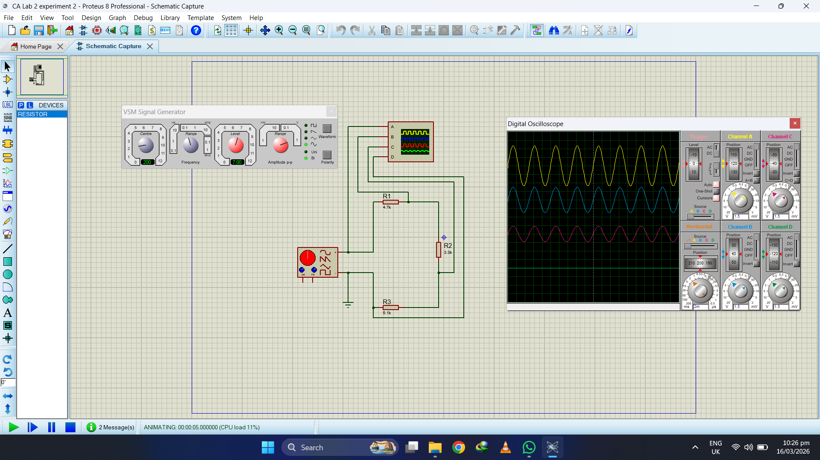
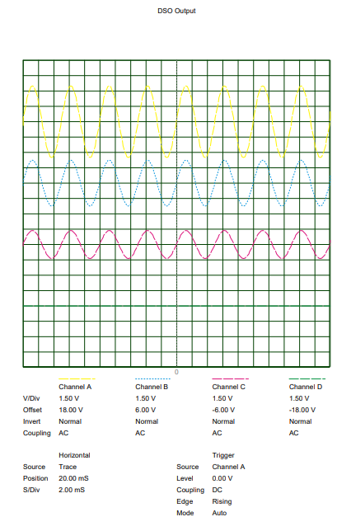

Conclusion
From the experiment, it is observed that the input signal is sinusoidal and the output signals across the resistors also remain sinusoidal. The voltage across each resistor is different due to the voltage divider effect in the series circuit.

